Friday, 11 September 2026, postcard

Paris, Louvre, La Petite Régalade, and David Toutain

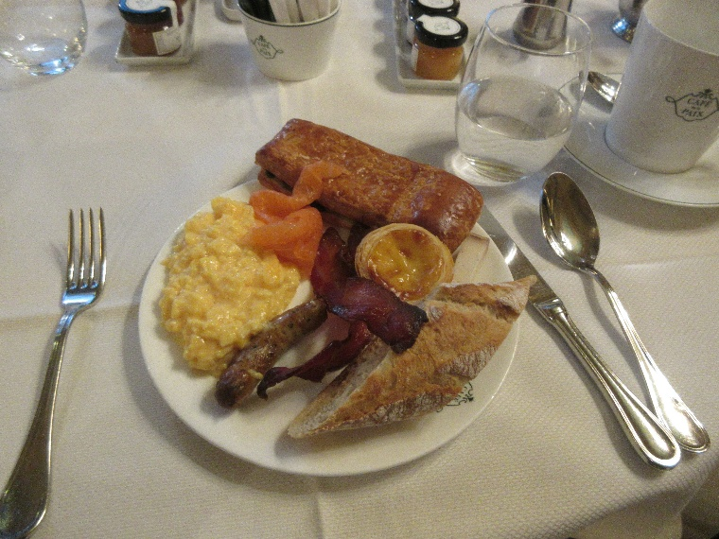
The breakfast buffet in Café de la Paix was excellent. Here's my plate: At the top, a "torsade" of chocolate that they didn't bother to twist, so call it a "flat chocolate twist." To the right of it, a little baton of "tomme de chevre," an excellent pressed goat's cheese. Below it, a Portugese "pastel de nata" and some American-style bacon. At the left-hand side, some smoked salmon, so-so scrambled eggs, and an absolutely outstanding little sausage. At the right, a slice of a whole-grain baguette.

People were raving, saying it was the best hotel breakfast buffet ever, but I would have to argue that the one at the Hyatt Regency Paris Étoile, where Viking put us in 2019 gave it a serious run for its money (see the 23 June 2019 entry in my travel diaries). But it was pretty darn good—six kinds of cheeses, eggs to order, tea made in pots right in the kitchen (they must get a lot of Brits)—nice.

Shortly after breakfast, they herded us onto buses for our panoramic tour of Paris. I tried to photograph the points of interest they showed us, starting with La Madeleine (Church of St. Mary Magdalen), which is entirely surrounded by columns like the parthenon, but all I could get through the bus windows was a view of half a dozen columns, both their tops and their bottoms cut off, and patchworked with reflections off the glass.

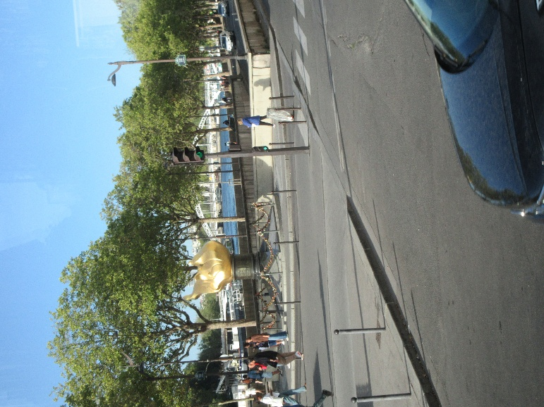
Next was the Place de la Concorde, currently full of preparations for the visit of some Asian head of state; the Grand Palais and Petit Palais; the length of the Champs Elysées to circle the Arc de Triomphe, the length of Avenue Kleber to Trocadero (for the great view of the Eiffel Tower); crossing the Alma Bridge (with a quick look at the flame monument marking the spot below which Diana Spencer was killed, shown here); the (relatively) new Greek Orthodox church; a particularly nice Art Nouveau façade XXXX; all to reach the view of the Eiffel Tower from the other side. A jarring note in the otherwise very good narration was the guide's insistence on translating everything into English—Concord Square for Place de la Concorde, Mars Field for the Champ de Mars—weird. The only French name she used was the Champs Elysées (which she did not call "the Elysian Fields").
Then a circle around the Invalides and on to the National Assembly building. Back over the river on the Alexander III bridge; the Conciergerie; across the façade of Notre Dame; and into the underground parking garage of the Louvre. I hadn't realized it had one!

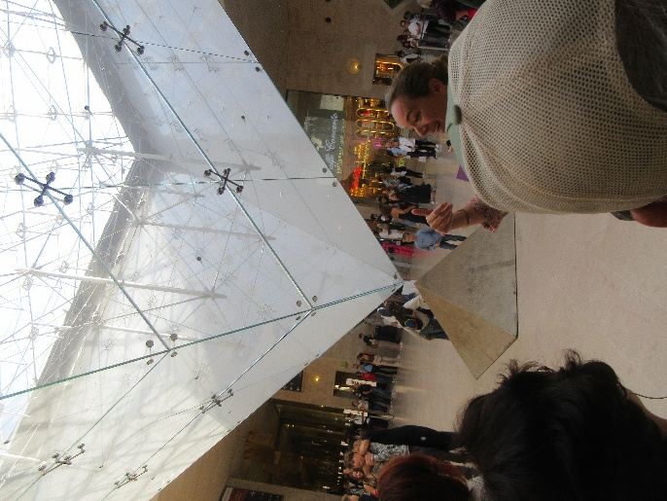
We walked into the lower level of the Louvre from the garage, through the Carousel du Louvre underground shopping mall, past the famous "inverted pyramid," and through security into the Louvre itself.

(When we were here with Rachel and 14-year-old Daniel Sinnet, he immediately ran over and tucked his head into the space between the glass and stone pyramids. I still have a photo of that somewhere. This is also the spot where The Da Vinci Code ends, and for years the museum had trouble with gullible people trying to dig it up.)

The security checkpoint has improved vastly. Instead of one guy with a little wooden table and a stick for poking through handbags, they now have two lanes, each with a walk-through metal detector and an X-ray machine to put purses and backpacks through.

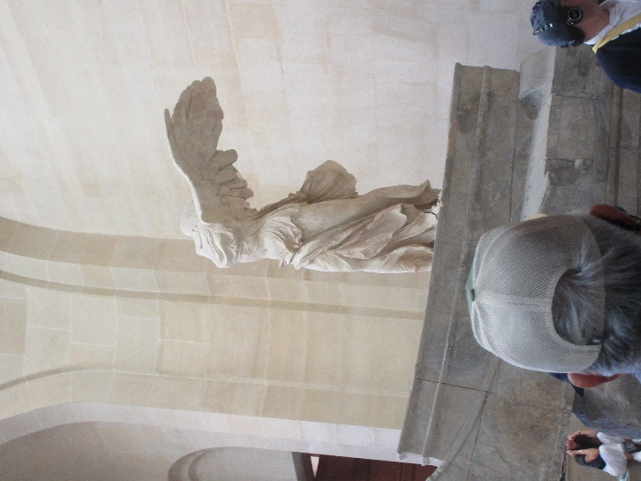
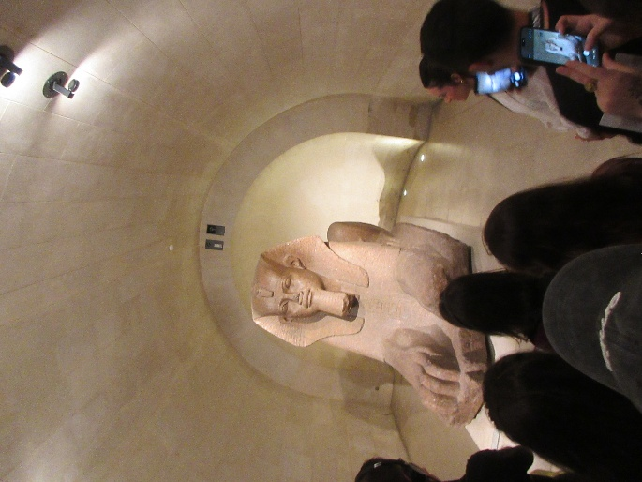
We'd been promised "highlights" of the Louvre, so I figured Vicky, Venus, and Mona for sure, and yes, we did see those, but the guide pointed out lots of other stuff on the way, like this sphinx, the largest outside Egypt. Our guide made a point of assuring us that none of the Egyption antiquities was looted. All of it was given to France by Egypt in gratitude for the work of the Frenchman who figured out how to read hierglyphics. (If I had wifi, I'd look up his name and include it here, but the ship's wifi is down at least until later today.)

Here's Vicky (the Winged Victory (aka Nike) of Samothrace), my favorite of the big three. The guide told us that the shape of the Nike swoosh is taken from the line of her wings and shoulders in this view.

Other highlights the guide paused to talk about were the martyrdom of St. Sebastian by Andrea Mantegna, three of the five Leonardo's the museum has (one was out on loan, and Mona has a room of her own now) and the Coronation of Napoleon by Jacques-Louis David

Then it back into the buses. We got back to the hotel just in time for David and me to duck around the corner and down the street to La Petite Régalade for our 1:45 pm lunch reservation.

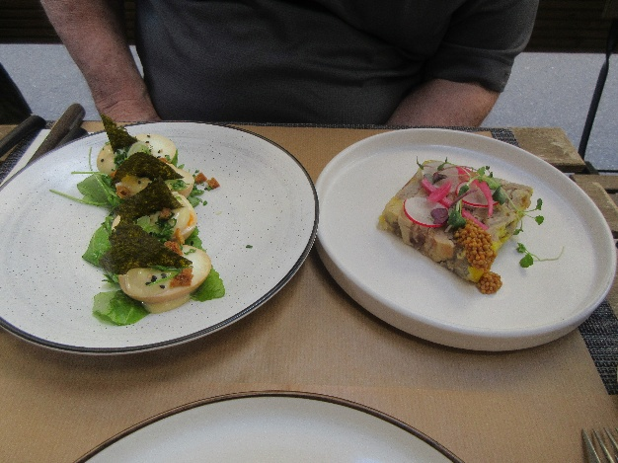
My sweetbreads with mashed potatoes and chanterelles were scrumptious, but David's two simultaneous appetizers were more photogenic:
On the right, a "pressée (compressed loaf) of duck thigh and duck foie gras with pickled mustard seeds. On the right "eggs mayonnaise" with miso, arugula sesame, and algae. The eggs were perfectly cooked, apparently in something that stained them slightly through the shells. The ,miso must have been mixed into the mayo. The little orange things were crispy croutons, and the "algae" was the triangles of nori standing up on top.

We split an order of rice pudding with caramel sauce for dessert.

After resting up at the hotel (and packing for tomorrow's early luggage pull), we had the bell captain call us a cab and headed off to long-time favorite David Toutain. We were early for our 7 pm reservations, but they seated us anyway, in a little four-table side room. After three rounds of amuse-bouches, we ordered the 8-course chef's choice menu with the 7-wine pairing for David and Rachel. We added a 9th course (sweetbreads) from a choice of up to four. I had already told them our allergies when I made the reservations.

Almost no repeats this time on the menu—only the very welcome reprise of the raspberry sugar shell stuffed with shallot cream and an oyster. So good! Here are a few of the more photogenic courses:

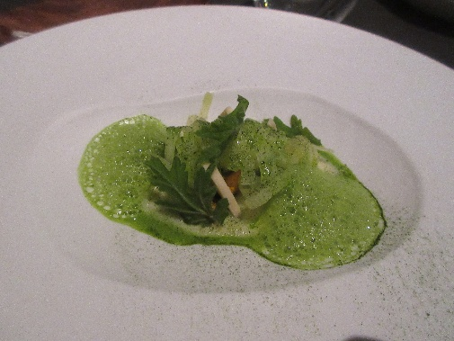
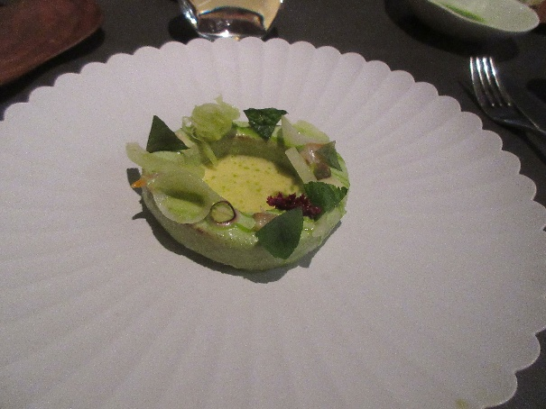
A ring of perfectly cooked solid kohlrabi garnished with paper thin slices and fine shreds of raw kohlrabi, together with various herbs, and filled with a buttery herb sauce. (David, while scarfing up the last bite, "but I don't like kohlrabi." Rachel, while doing the same thing, "What's a kohlrabi?")

Then a "vichyssoise" where the white parts of baby leeks were cut into rings, draped over a little pile of chanterelles, then covered with lightly cooked potato shreds, in turn smothered in a bright green leek foam. Very yummy!
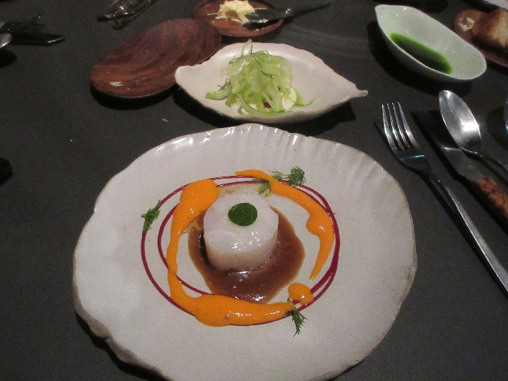
Here's the perfectly poached cod David and I were served, surrounded by delicious creamy purées of two different sweet peppers.

Behind it, a dish of crispy fennel salad (and a dish of dark green herb oil left over from an earlier course, for dipping bay-leaf bread in).

Because Rachel is allergic to fish, she was served a wedge of tender braised fennel with the same sauces. (Rachel, chasing the last bits around the plate, "But I don't like fennel.")

After those courses and five others culminating in sweetbreads, roast pigeon, two desserts, and strawberry truffle mignardises (plus a champagne apperitif and eight other carefully chosen wines for the others), we reeled out the door and into a cab back to the hotel. We got there about 11:45 pm and had to have our luggage ready for pick-up by 7 am. Totally worth it.

